|  |  |
| --- | --- |
| Course Name | ITD 2313 – Script Programming |
| Instructor | Mr. Pranger |
| Student Name | Trey Mobley |
| Due date | 07/14/2021 |
| Grade | <grade earned here> |
| Grading Comments | <instructor comments here> |

Pg. 203-204

Project #5

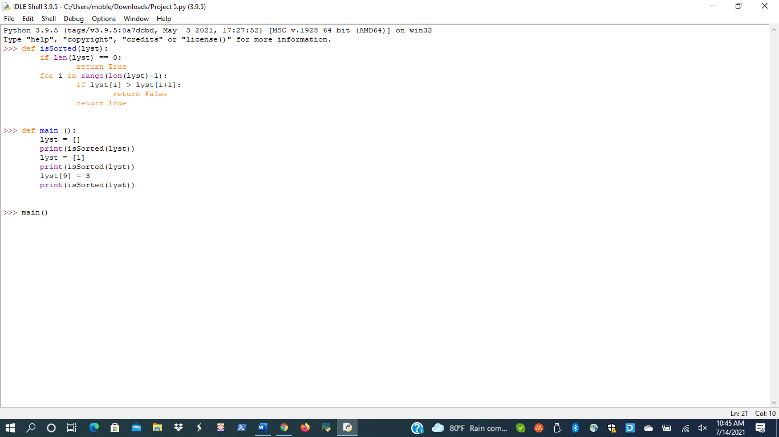



Project # 8



Project # 9

